

DEPARTMENT OF BIOMEDICAL ENGINEERING

AIR QUALITY MONITORING

PHASE 4 DOCUMENT SUBMISSION

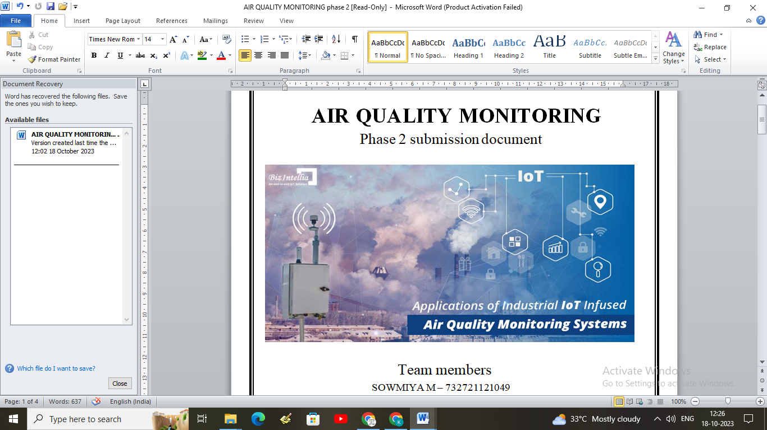

TEAM MEMBERS

**SOWMIYA M – 732721121049**

**PAVITHRA C T – 732721121038**

**SWETHA G K – 732721121054**

**KANISHKA S – 732721121021**

**NISHANTHINI T – 732721121034**

**INTRODUCTION:**

Air quality monitoring plays a crucial role in assessing and understanding the levels of various pollutants present in the atmosphere. It involves the systematic collection, analysis, and interpretation of data related to air pollutants to evaluate the overall air quality in a specific region. With the rise in urbanization, industrialization, and various human activities, the need for effective air quality monitoring has become increasingly important to safeguard public health and the environment. Through the use of advanced technologies and monitoring stations, data is collected on various pollutants such as particulate matter, volatile organic compounds, carbon monoxide, sulfur dioxide, nitrogen oxides, and ozone. This data is then analyzed to assess the potential health risks and environmental impacts associated with poor air quality.

**OVERVIEW OF THE PROCESS:**

**Selection of Monitoring Stations:**  Strategic locations are chosen to set up monitoring stations, considering factors such as proximity to pollution sources, population centers, and geographical features that may influence air circulation patterns.

**Data Collection:** Monitoring stations use specialized equipment and instruments to collect data on various air pollutants, including particulate matter, ozone, carbon monoxide, sulfur dioxide, nitrogen dioxide, and volatile organic compounds. Data collection can be continuous, semi-continuous, or periodic, depending on the specific monitoring requirements and objectives.

**Data Processing and Analysis:** The collected data undergoes rigorous processing and analysis to derive meaningful insights into air quality trends, pollutant concentrations, and potential health risks. Statistical techniques and modeling may be employed to interpret the data and identify patterns or anomalies.

**Quality Assurance and Quality Control (QA/QC):** Rigorous QA/QC measures are implemented to ensure the accuracy, reliability, and consistency of the collected data. This involves regular calibration of monitoring equipment, adherence to standard operating procedures, and validation of data against established quality standards and guidelines.

**Data Reporting and Dissemination:** The analyzed data is compiled into comprehensive reports and made accessible to the public, relevant stakeholders, and policymakers. This transparency helps raise awareness about air quality issues and facilitates informed decision-making for implementing effective air quality management strategies.

**Impact Assessment and Policy Formulation:** The findings from air quality monitoring are used to assess the potential environmental and health impacts of air pollution. Based on these assessments, policymakers can develop and implement targeted policies, regulations, and interventions aimed at reducing pollution levels and improving overall air quality.

**Long-Term Monitoring and** **Trend Analysis:** Continuous monitoring and trend analysis allow for the evaluation of the effectiveness of implemented measures and the identification of emerging air quality challenges. Long-term data trends help in forecasting future air quality scenarios and adapting strategies to meet evolving environmental and public health needs.

**MODEL TRAINING:**

**Data Collection:** The first step in model training is the collection of comprehensive and high-quality data related to air quality parameters, meteorological conditions, geographical features, and other relevant factors. This data can be obtained from various monitoring stations, satellite observations, and other sources.

**Data Preprocessing:** The collected data is preprocessed to handle missing values, outliers, and inconsistencies. This step involves data cleaning, normalization, and transformation to ensure that the data is suitable for model training and analysis.

**Feature Selection and Engineering:** Relevant features that significantly influence air quality are selected and engineered to create meaningful input variables for the model. This step involves identifying key predictors, transforming variables, and creating new features that can enhance the model's predictive capabilities.

**Model Selection:** Based on the specific requirements and characteristics of the data, suitable modeling techniques are selected. Commonly used models for air quality monitoring include statistical models (e.g., linear regression, time series analysis), deterministic models (e.g., Gaussian dispersion models), and machine learning models (e.g., random forest, support vector machines, neural networks).

**Model Training:** The selected model is trained using historical data to learn the relationships between various input features and air quality parameters. During the training process, the model adjusts its internal parameters to minimize the difference between predicted values and actual observations.

**Model Evaluation:** Trained models are rigorously evaluated using validation datasets to assess their performance, accuracy, and robustness. Various evaluation metrics such as mean squared error, root mean squared error, and coefficient of determination (R-squared) are used to measure the model's predictive capabilities.

**Model Optimization:** Model parameters are fine-tuned and optimized to improve performance and generalization capabilities. Techniques such as cross-validation, hyperparameter tuning, and regularization are applied to enhance the model's ability to generalize to unseen data and prevent overfitting.

**Model Deployment:** Once a satisfactory level of performance is achieved, the trained model is deployed for real-time or near-real-time air quality prediction and monitoring. This deployment may involve integrating the model into a user-friendly interface or an operational system that provides timely and accurate air quality information to stakeholders and the general public.

.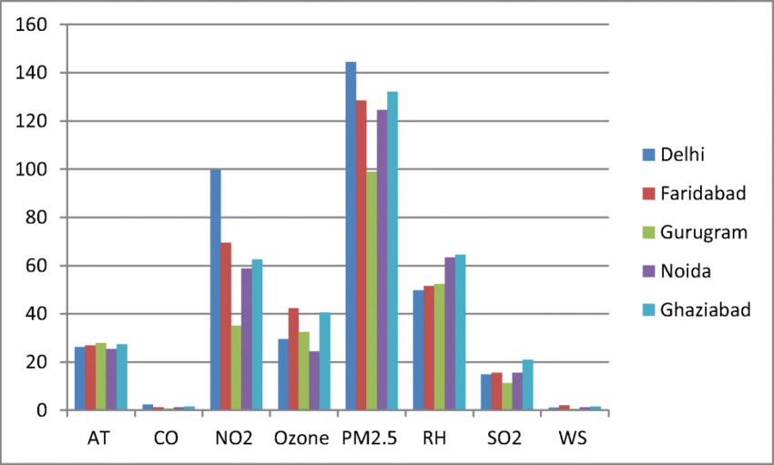

**MODEL EVALUATION:**

**Data Collection:** The first step in model training is the collection of comprehensive and high-quality data related to air quality parameters, meteorological conditions, geographical features, and other relevant factors. This data can be obtained from various monitoring stations, satellite observations, and other sources.

**Data Preprocessing:** The collected data is preprocessed to handle missing values, outliers, and inconsistencies. This step involves data cleaning, normalization, and transformation to ensure that the data is suitable for model training and analysis.

**Feature Selection and Engineering:** Relevant features that significantly influence air quality are selected and engineered to create meaningful input variables for the model. This step involves identifying key predictors, transforming variables, and creating new features that can enhance the model's predictive capabilities.

**Model Selection:** Based on the specific requirements and characteristics of the data, suitable modeling techniques are selected. Commonly used models for air quality monitoring include statistical models (e.g., linear regression, time series analysis), deterministic models (e.g., Gaussian dispersion models), and machine learning models (e.g., random forest, support vector machines, neural networks).

**Model Training:** The selected model is trained using historical data to learn the relationships between various input features and air quality parameters. During the training process, the model adjusts its internal parameters to minimize the difference between predicted values and actual observations.

**Model Evaluation:** Trained models are rigorously evaluated using validation datasets to assess their performance, accuracy, and robustness. Various evaluation metrics such as mean squared error, root mean squared error, and coefficient of determination (R-squared) are used to measure the model's predictive capabilities.

**Model Optimization:** Model parameters are fine-tuned and optimized to improve performance and generalization capabilities. Techniques such as cross-validation, hyperparameter tuning, and regularization are applied to enhance the model's ability to generalize to unseen data and prevent overfitting.

**Model Deployment:** Once a satisfactory level of performance is achieved, the trained model is deployed for real-time or near-real-time air quality prediction and monitoring. This deployment may involve integrating the model into a user-friendly interface or an operational system that provides timely and accurate air quality information to stakeholders and the general public.

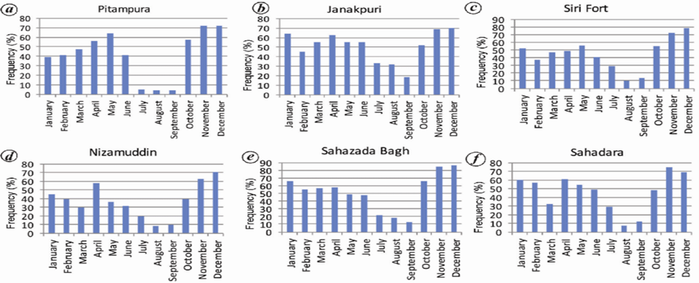

**PROGRAM:**

// Include the necessary libraries

#include <Wire.h>

#include <LiquidCrystal_I2C.h>

// Initialize the LCD screen

LiquidCrystal_I2C lcd(0x27, 16, 2); // Change the address based on your LCD settings

// Define the analog pin for the sensor

int sensorPin = A0;

void setup() {

// Initialize the LCD screen

lcd.begin();

lcd.backlight();

// Set up the serial communication

Serial.begin(9600);

}

void loop() {

// Read the sensor value

int sensorValue = analogRead(sensorPin);

// Convert the sensor value to the corresponding air quality level

// Add your own calibration values based on the sensor datasheet

int airQuality = map(sensorValue, 0, 1023, 0, 100);

// Display the air quality on the LCD screen

lcd.setCursor(0, 0);

lcd.print("Air Quality: ");

lcd.print(airQuality);

lcd.print("%");

// Display the raw sensor value on the serial monitor

Serial.print("Sensor Value: ");

Serial.println(sensorValue);

// Add a delay for stability (adjust as needed)

delay(1000);

}

**FEATURE ENGINEERING:**

**Particulate Matter (PM):** Monitoring the concentration of fine particles (PM2.5 and PM10) in the air is essential as these particles can penetrate deep into the respiratory system, causing adverse health effects.

**Gaseous Pollutants:** Monitoring various gaseous pollutants such as carbon monoxide (CO), sulfur dioxide (SO2), nitrogen oxides (NOx), ozone (O3), and volatile organic compounds (VOCs) helps in assessing the overall air quality and understanding the sources of pollution.

**Meteorological Parameters:** Monitoring meteorological parameters such as temperature, humidity, wind speed, and wind direction is crucial for understanding the dispersion and transport of air pollutants in the atmosphere.

**Air Quality Index (AQI):** The Air Quality Index provides a standardized way to communicate air quality levels to the public. Monitoring the AQI helps in categorizing the quality of the air and informing the public about the potential health risks associated with the current air quality conditions.

**Geographical and Spatial Data:** Monitoring geographical and spatial data, including the location of monitoring stations, industrial zones, traffic patterns, and land use, helps in identifying hotspots and understanding the spatial distribution of air pollutants.

**Emission Sources:** Monitoring the sources of emissions, such as industrial facilities, vehicular traffic, construction sites, and residential heating, is crucial for implementing targeted pollution control measures and regulations.

**Long-Term Trends:** Monitoring long-term trends in air quality data helps in identifying changes in pollutant levels over time, assessing the effectiveness of pollution control measures, and predicting future air quality scenarios.

**Public Health Impact:** Monitoring the impact of air pollution on public health, including the prevalence of respiratory diseases, cardiovascular problems, and other health-related issues, provides insights into the direct consequences of poor air quality on human well-being.

**CHALLENGES OF THE AIR QUALITY MONITORING SYSTEM:**

**Cost and Infrastructure:** Setting up and maintaining a comprehensive air quality monitoring network requires significant financial resources and infrastructure. The costs associated with procuring monitoring equipment, establishing monitoring stations, and ensuring data transmission and storage can be substantial, especially for developing regions or areas with limited resources.

**Data Quality and Standardization:** Ensuring the quality and standardization of data collected from various monitoring stations can be challenging. Discrepancies in data collection methods, calibration procedures, and quality control measures across different stations can lead to inconsistencies and inaccuracies, making it difficult to compare and analyze data accurately.

**Sensor Accuracy and Reliability:** Deploying accurate and reliable air quality sensors is crucial for obtaining precise measurements of air pollutants. However, maintaining sensor calibration, addressing sensor drift, and ensuring sensor durability in harsh environmental conditions pose significant challenges that can affect the overall reliability of the monitoring system.

**Data Interpretation and Analysis:** Processing and interpreting vast amounts of air quality data require sophisticated analytical tools and expertise. Analyzing complex data sets, identifying trends, and understanding the interrelationships between different pollutants and meteorological parameters demand advanced data analysis techniques and skilled personnel.

**Technological Limitations:** Technological limitations, such as the lack of real-time data transmission capabilities, limited sensor capabilities for detecting specific pollutants, and the inability to monitor certain emerging pollutants, can constrain the effectiveness of the air quality monitoring system in providing timely and comprehensive information.

**Spatial and Temporal Variability:** Accounting for spatial and temporal variability in air quality measurements poses challenges, particularly in regions with diverse geographical features and varying sources of pollution. Capturing variations in pollutant concentrations over different time periods and locations requires a well-designed monitoring network that accounts for these complexities.

**Public Awareness and Engagement:** Promoting public awareness and engagement in understanding air quality data and its implications is crucial. Communicating complex scientific information in a comprehensible manner and fostering public participation in air quality management initiatives are essential challenges that require effective communication strategies and community involvement.



**CONCLUSION:** As the field of air quality monitoring continues to evolve, sustained emphasis on innovative feature engineering methodologies and advancements in data analytics will be indispensable for unraveling the intricate dynamics of air quality. By fostering a culture of continuous improvement and knowledge exchange, feature engineering serves as a catalyst for fostering resilient, data-driven decision-making processes and cultivating a healthier, more sustainable living environment for present and future generations.